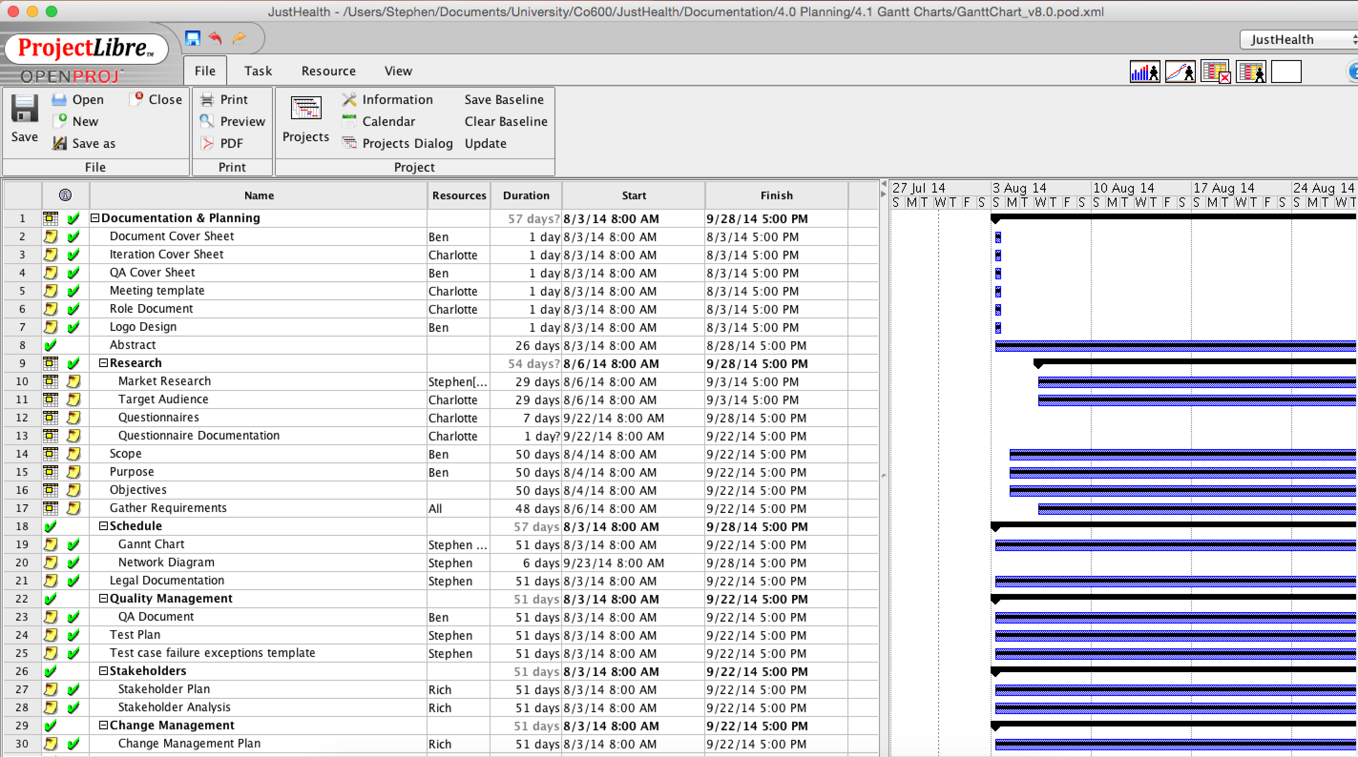Initially, we started developing our Gantt chart in Excel (Corpus Index: Initial Gantt chart), however this proved ineffective and therefore we used an Open Source software called ProjectLibre (Corpus Index: Final Gantt chart). Below are some screen shots of the ProjectLibre program that we used to create our Gantt chart, which can be used as an example. If you would like to view the entirety of the Gantt chart, you can download ProjectLibre (<http://www.projectlibre.org>) and import the XML file that is linked from the Corpus Index.

